S-Mart Applications – Known Bugs

1. Map - Icon locations offside is incorrect
2. 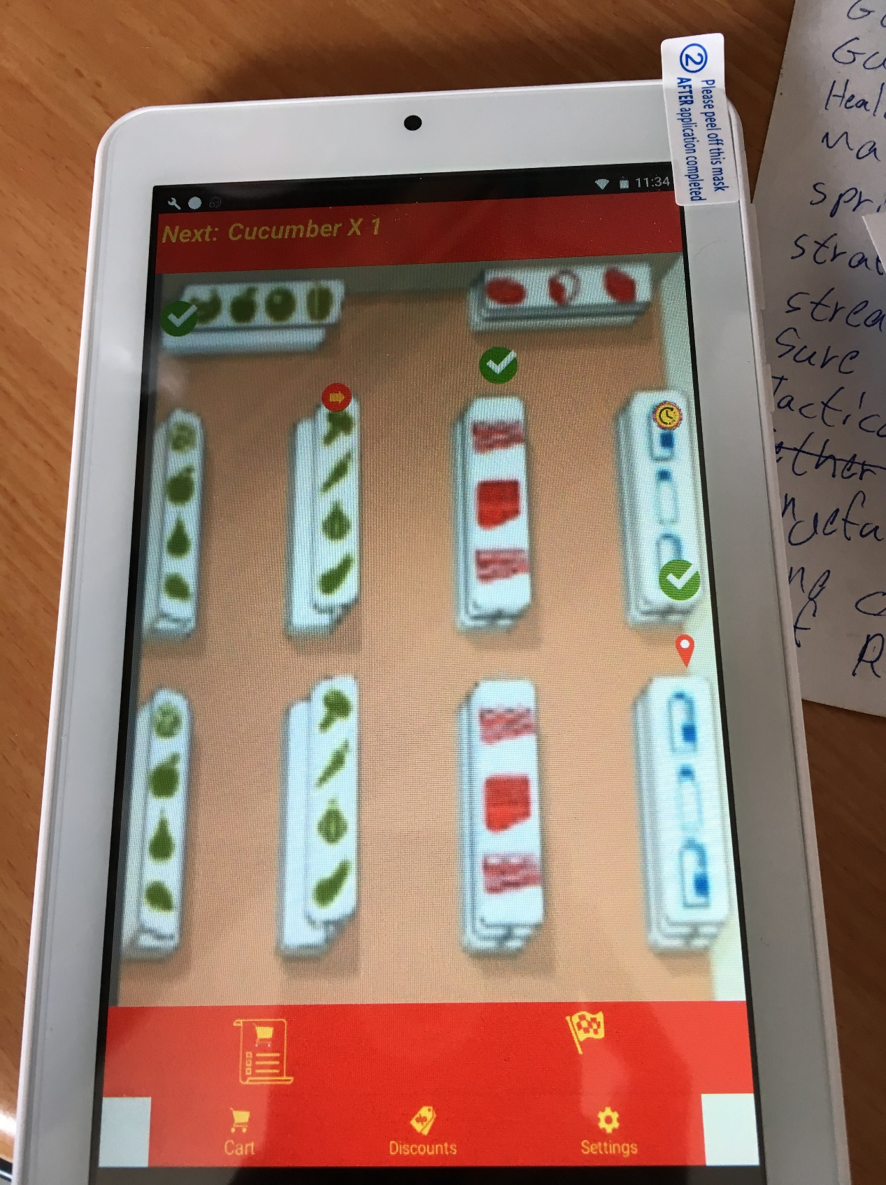Map - Finish icon is smaller
3. Map – GridView squares height is too big

* GridView sizes are 14x10, but on Acer Iconia One 7 you can only touch/see 8x10.
* You can't see all icons.

1. Android - onDestroy() doesn't always being called

* When you exit the application, Logout request is not always being made immediately.
* It is an android operating system problem…